[](https://www.comsol.com/)

Lab4 Q1 CounterCurrent

Report date

Dec 3, 2024, 5:42:16 PM

Contents

1. Global Definitions 3

1.1. Parameters 3

1.2. Materials 3

2. Component 1 4

2.1. Definitions 4

2.2. Geometry 1 4

2.3. Materials 5

2.4. Laminar Flow 5

2.5. Heat Transfer in Solids and Fluids 3 6

2.6. Mesh 1 7

3. Study 1 8

3.1. Stationary 8

4. Results 9

4.1. Datasets 9

4.2. Derived Values 11

4.3. Tables 12

4.4. Plot Groups 13

1. Global Definitions

|  |  |
| --- | --- |
| Date | Dec 3, 2024, 5:08:23 PM |

Global settings

|  |  |
| --- | --- |
| Name | Lab4 Q1 CounterCurrent.mph |
| Path | C:\Users\a3dufres\Downloads\Lab4 Q1_CounterCurrent.mph |
| Version | COMSOL Multiphysics 6.1 (Build: 282) |

Used products

|  |
| --- |
| COMSOL Multiphysics |

Computer information

|  |  |
| --- | --- |
| CPU | Intel64 Family 6 Model 183 Stepping 1, 20 cores, 31.82 GB RAM |
| Operating system | Windows 10 |

* 1. Parameters

Parameters 1

| **Name** | **Expression** | **Value** | **Description** |
| --- | --- | --- | --- |
| Thick | 0.001 [m] | 0.001 m | Thickness of the Copper Tube |
| Di | 0.1 [m] | 0.1 m | Radius of Inner Tube |
| D | 2*Di + Thick | 0.201 m | Radius of Outer Tube |
| K_Cop | 385 [W/(K*m)] | 385 W/(m·K) | Copper Thermal Conductivity |
| rho | 998 [kg/m^3] | 998 kg/m³ | Density of Water |
| vis | 0.001 [Pa*s] | 0.001 Pa·s | Viscosity of Water |
| Cp | 4182 [J/(kg*K)] | 4182 J/(kg·K) | Specific Heat capacity of Water |
| K_Water | 0.6 [W/(m*K)] | 0.6 W/(m·K) | Thermal Conductivity of Water |
| T_Hot | 80 [degC] | 353.15 K | Temperature of the Hot Water |
| V_Hot | 0.02 [m/s] | 0.02 m/s | Speed of the Hot Water |
| T_Cold | 20 [degC] | 293.15 K | Temperature of the Cold Water |
| V_Cold | 0.01 [m/s] | 0.01 m/s | Speed of the Cold Water |
| Length | 0.5 [m] | 0.5 m | Length of the Tube |
| Ri | Di/2 | 0.05 m | Diameter of Inner Tube |
| R_Tot | 2*Ri + Thick | 0.101 m |  |

* 1. Materials
     1. Copper 1

1. Component 1
   1. Definitions
      1. Coordinate Systems

#### Boundary System 1

|  |  |
| --- | --- |
| Coordinate system type | Boundary system |
| Tag | sys1 |

Coordinate names

| **First** | **Second** | **Third** |
| --- | --- | --- |
| t1 | to | n |

* 1. Geometry 1

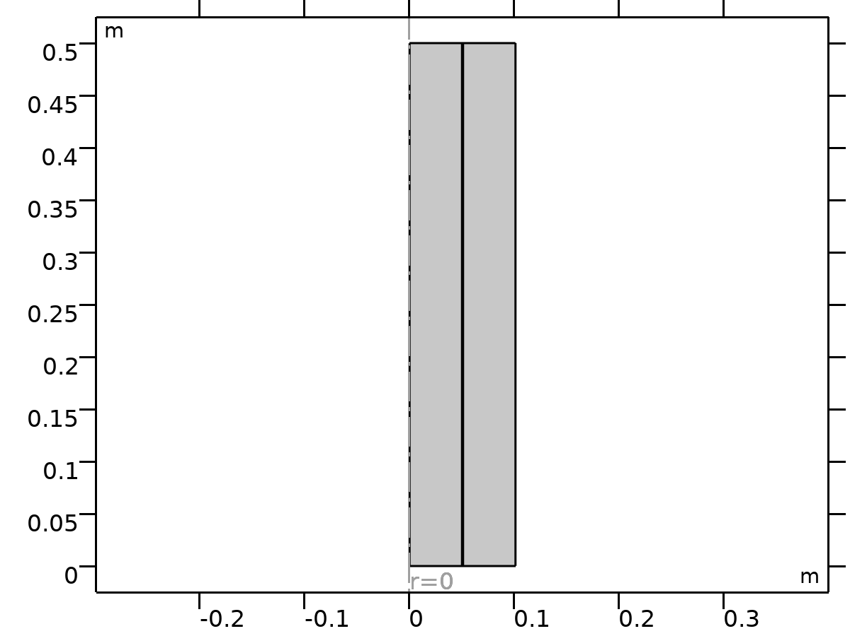

Geometry 1

Units

|  |  |
| --- | --- |
| Length unit | m |
| Angular unit | deg |

* 1. Materials
     1. Copper

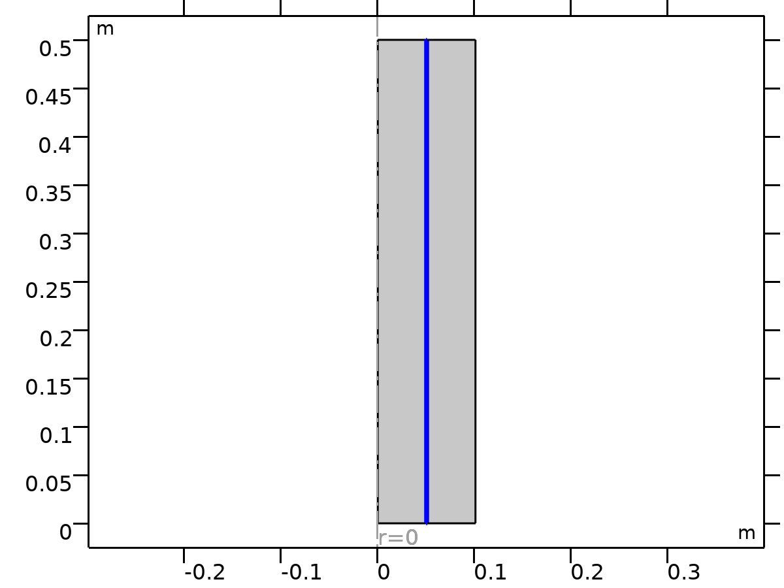

Copper

Selection

|  |  |
| --- | --- |
| Geometric entity level | Domain |
| Selection | Geometry geom1: Dimension 2: Domain 2 |

* 1. Laminar Flow

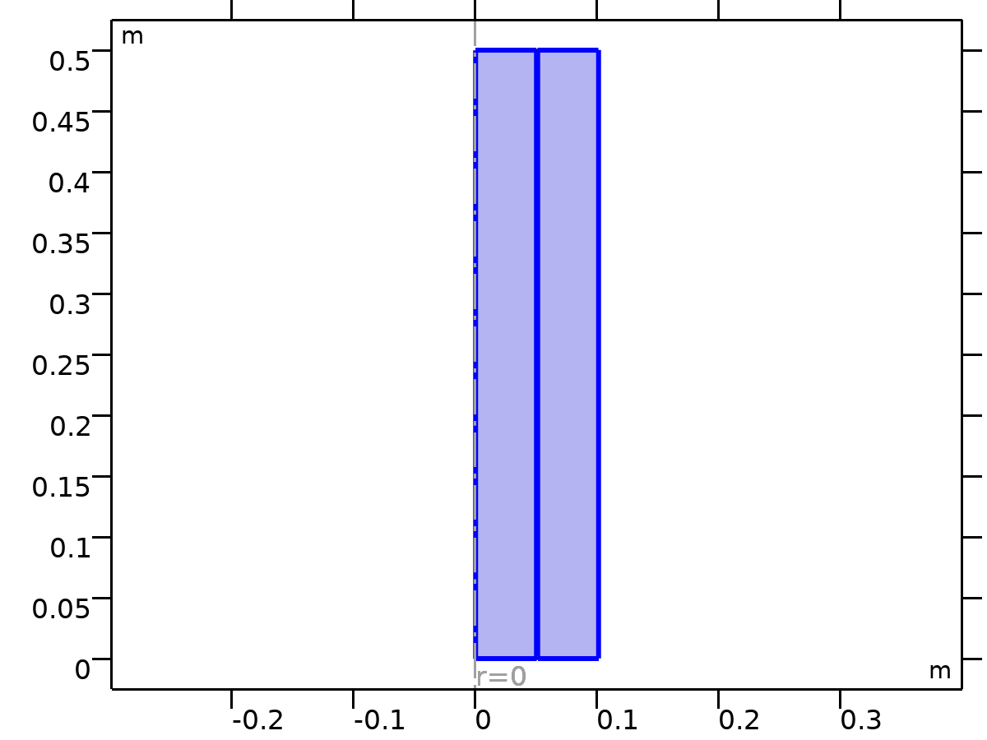

Laminar Flow

Equations





Features

| **Name** | **Level** |
| --- | --- |
| Fluid Properties 1 | Domain |
| Initial Values 1 | Domain |
| Axial Symmetry 1 | Boundary |
| Wall 1 | Boundary |
| Hot Water In | Boundary |
| Cold Water In | Boundary |
| Hot Water Out | Boundary |
| Cold Water Out | Boundary |

* 1. Heat Transfer in Solids and Fluids 3

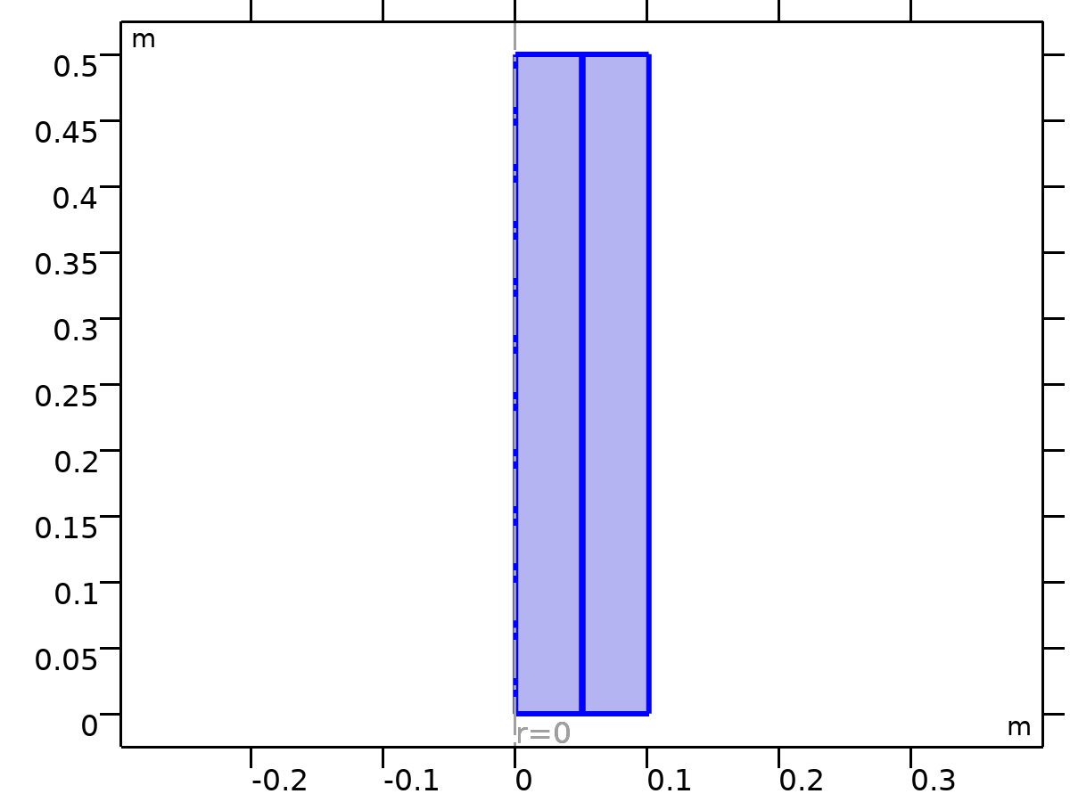

Heat Transfer in Solids and Fluids 3

Equations





Features

| **Name** | **Level** |
| --- | --- |
| Copper | Domain |
| Water Hot | Domain |
| Initial Values 1 | Domain |
| Axial Symmetry 1 | Boundary |
| Thermal Insulation 1 | Boundary |
| Cold Water Temp | Boundary |
| Hot Water Temp | Boundary |
| Cold Water Outflow | Boundary |
| Water Cold | Domain |
| Hot Water Outflow | Boundary |

* 1. Mesh 1

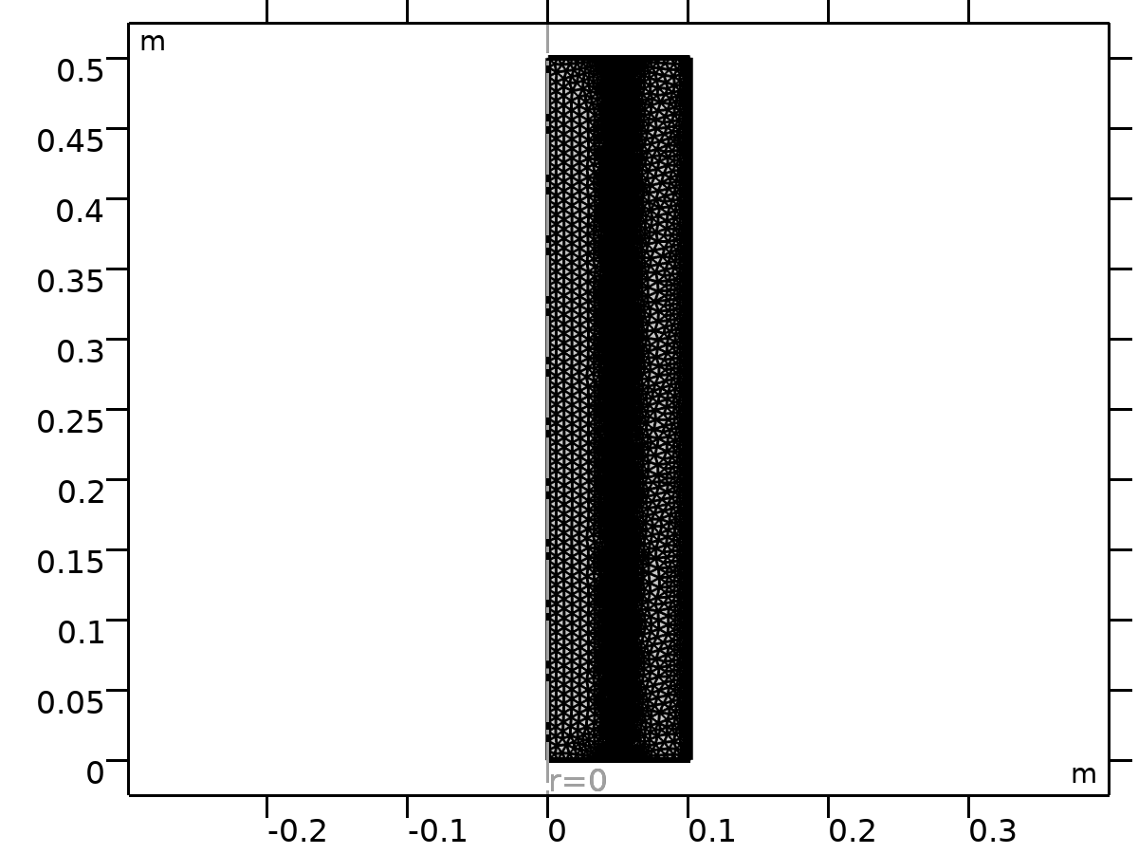

Mesh 1

1. Study 1

Computation information

|  |  |
| --- | --- |
| Computation time | 4 s |

* 1. Stationary

Study settings

| **Description** | **Value** |
| --- | --- |
| Include geometric nonlinearity | Off |

Physics and variables selection

| **Physics interface** | **Solve for** | **Equation form** |
| --- | --- | --- |
| Laminar Flow (spf) | On | Automatic (Stationary) |
| Heat Transfer in Solids and Fluids 3 (ht3) | On | Automatic (Stationary) |

Mesh selection

| **Component** | **Mesh** |
| --- | --- |
| Component 1 | Mesh 1 |

1. Results
   1. Datasets
      1. Study 1/Solution 1

Solution

| **Description** | **Value** |
| --- | --- |
| Solution | Solution 1 |
| Component | Component 1 (comp1) |

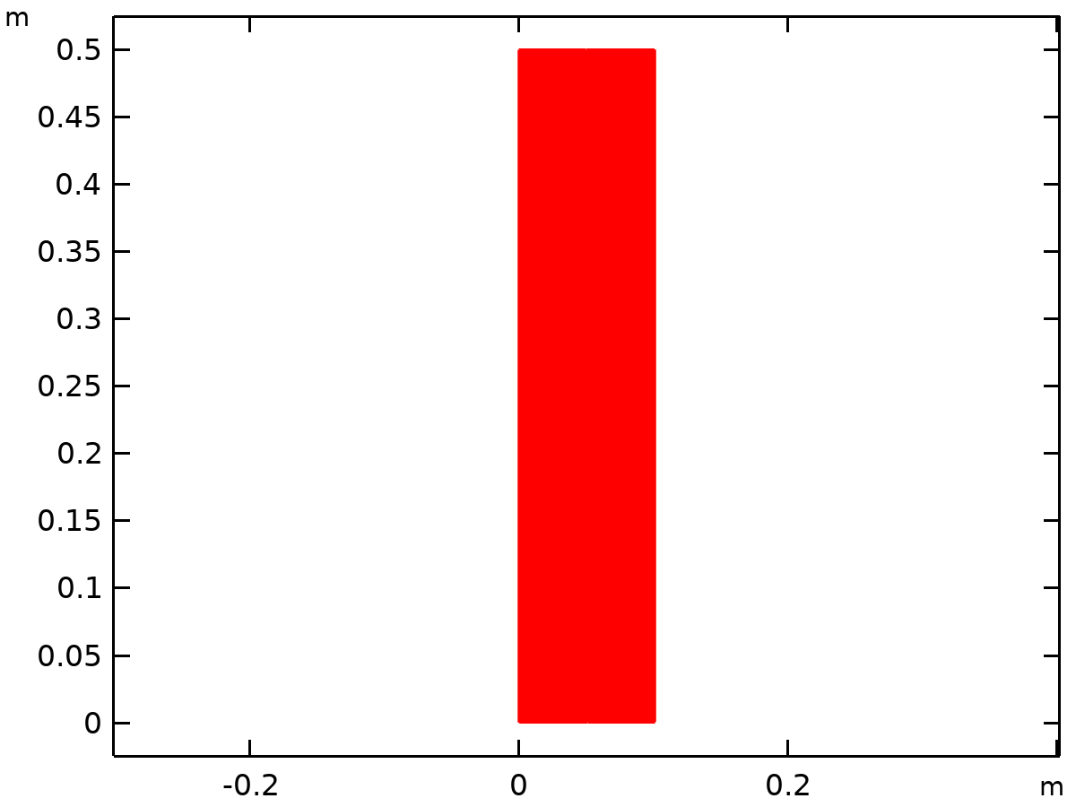

Dataset: Study 1/Solution 1

* + 1. Revolution 2D

Data

| **Description** | **Value** |
| --- | --- |
| Dataset | Study 1/Solution 1 |

Axis data

| **Description** | **Value** |
| --- | --- |
| Axis entry method | Two points |
| Points | {{0, 0}, {0, 1}} |

Revolution layers

| **Description** | **Value** |
| --- | --- |
| Start angle | -90 |
| Revolution angle | 225 |

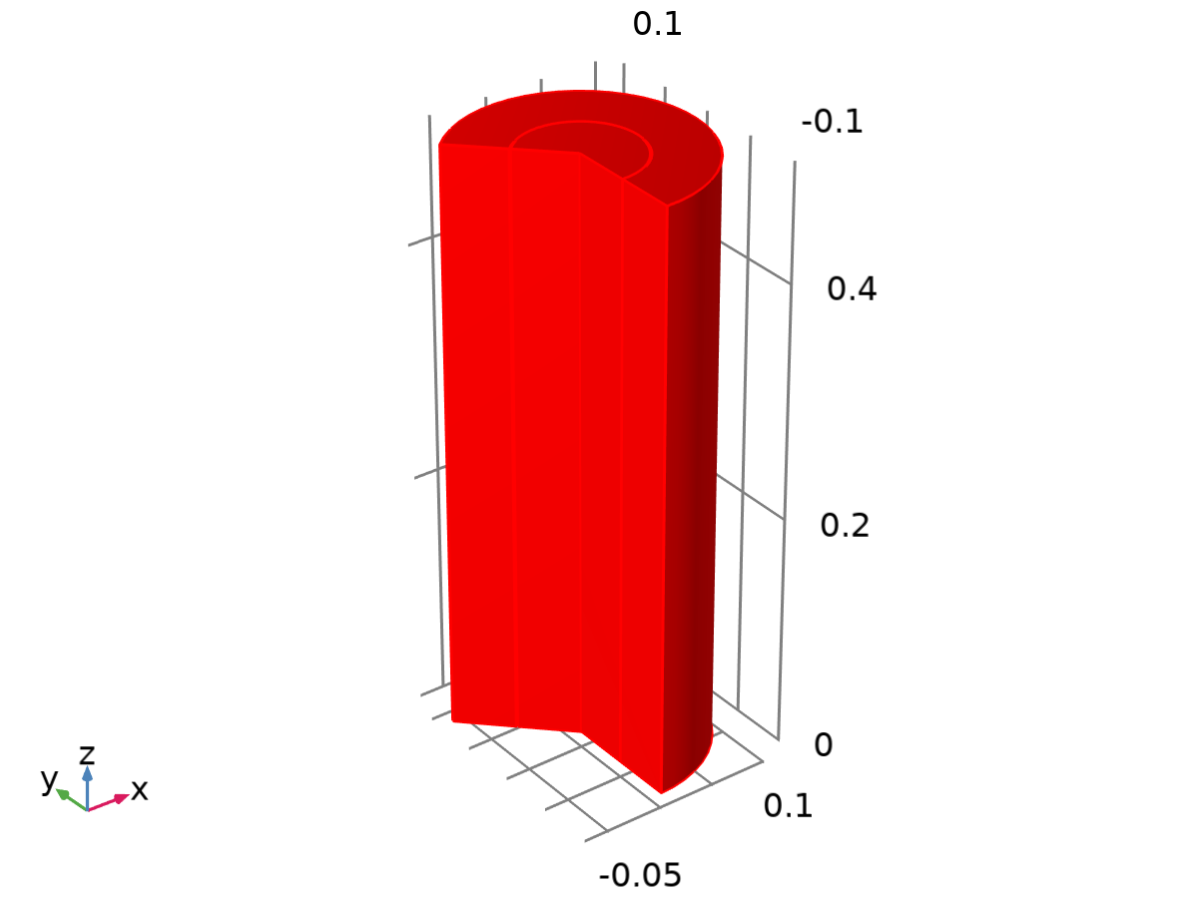

Dataset: Revolution 2D

* + 1. Study 1/Parametric Solutions 1

Solution

| **Description** | **Value** |
| --- | --- |
| Solution | Parametric Solutions 1 |
| Component | Component 1 (comp1) |

* + 1. Cut Line

Data

| **Description** | **Value** |
| --- | --- |
| Dataset | Study 1/Solution 1 |

Line data

| **Description** | **Value** |
| --- | --- |
| Line entry method | Two points |
| Points | {{0, Length/2}, {R_Tot, Length/2}} |

Advanced

| **Description** | **Value** |
| --- | --- |
| Space variable | cln1x |
| Normal variables | {cln1nx, cln1ny} |
| Tangent variables | {cln1tx, cln1ty} |

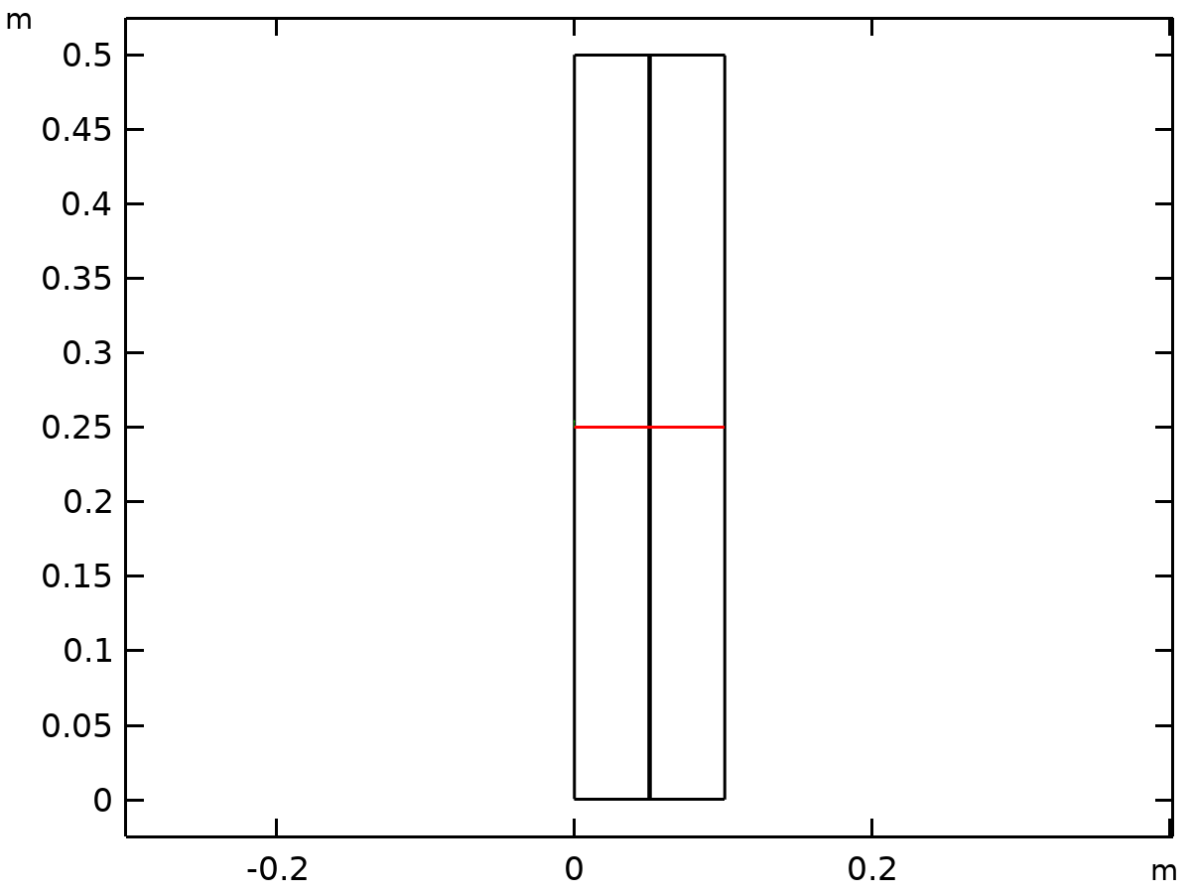

Dataset: Cut Line

* 1. Derived Values
     1. Hot Water Avg Out

Output

|  |  |
| --- | --- |
| Evaluated in | Table 6 |

Data

| **Description** | **Value** |
| --- | --- |
| Dataset | Study 1/Solution 1 |

Expressions

| **Expression** | **Unit** | **Description** |
| --- | --- | --- |
| T3 | K | Temperature |

Integration settings

| **Description** | **Value** |
| --- | --- |
| Integration order | 4 |
| Compute surface integral | On |

* + 1. Cold Water Avg Out

Output

|  |  |
| --- | --- |
| Evaluated in | Table 5 |

Data

| **Description** | **Value** |
| --- | --- |
| Dataset | Study 1/Solution 1 |

Expressions

| **Expression** | **Unit** | **Description** |
| --- | --- | --- |
| T3 | K | Temperature |

Integration settings

| **Description** | **Value** |
| --- | --- |
| Integration order | 4 |
| Compute surface integral | On |

* 1. Tables
     1. Evaluation 3D

Interactive 3D values

| **x** | **y** | **z** | **Value** |
| --- | --- | --- | --- |
| 0.049186 | 0.053169 | 0.5 | 321.02 |
| 0.015289 | 0.011451 | 0.5 | 321.02 |
| 0.032141 | 0.041288 | 0.5 | 321.02 |
| 1.5774E-4 | -0.007018 | 0.5 | 321.02 |
| 0.013571 | -0.040626 | 0.5 | 321.02 |
| 0 | -0.081705 | 0.4376 | 321.02 |

* + 1. Table 3

Hot Temp Avg

| **Temperature (K)** | **Temperature (K)** |
| --- | --- |
| 350.56 | 351.03 |

* + 1. Table 4

Cold Temp Avg

| **Temperature (K)** |
| --- |
| 294.56 |

* + 1. Table 5

Cold Water Avg Out

| **Temperature (K)** | **Temperature (K)** |
| --- | --- |
| 295.49 | 295.49 |

* + 1. Table 6

Hot Water Avg Out

| **Temperature (K)** | **Temperature (K)** |
| --- | --- |
| 348.45 | 348.45 |

* 1. Plot Groups
     1. Velocity (spf)

[COMSOLlink[]]

Surface: Velocity magnitude (m/s)

* + 1. Pressure (spf)

[COMSOLlink[]]

Contour: Pressure (Pa)

* + 1. Velocity, 3D (spf)

[COMSOLlink[]]

Surface: Velocity magnitude (m/s)

* + 1. Temperature, 3D (ht3)

[COMSOLlink[]]

Surface: Temperature (K)

* + 1. Isothermal Contours (ht3)

[COMSOLlink[]]

Contour: Temperature (K)

* + 1. 1D Plot Group 6

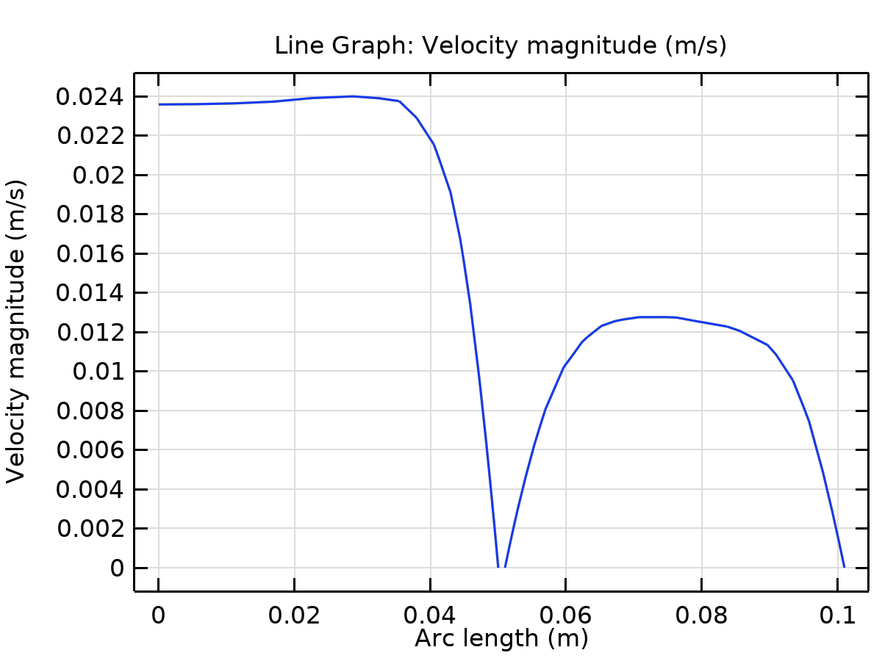

Line Graph: Velocity magnitude (m/s)

* + 1. Temperature Group

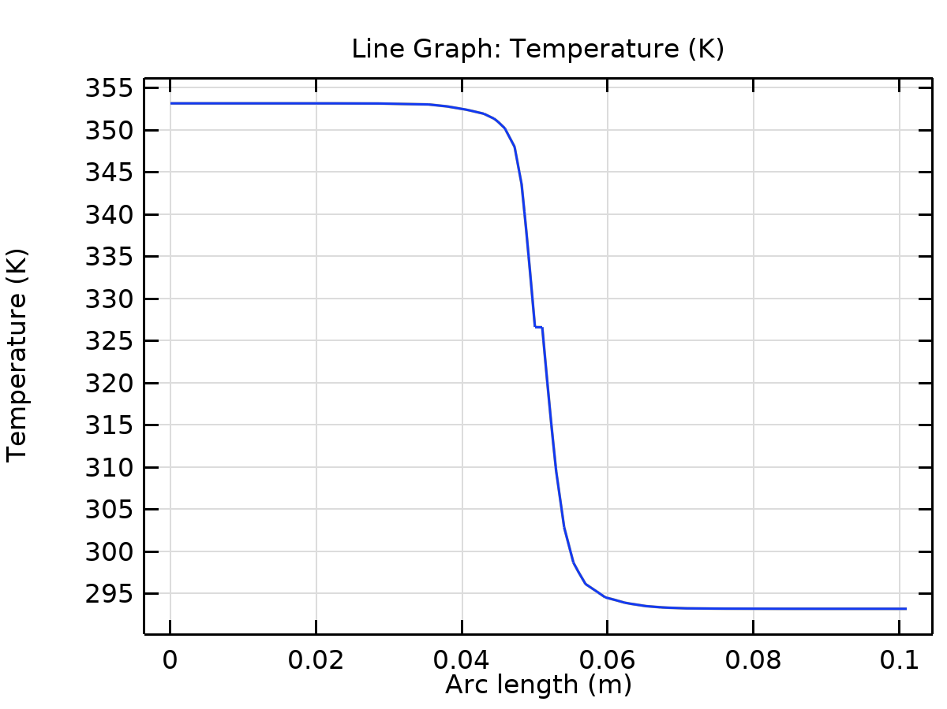

Line Graph: Temperature (K)